Step-by-Step: Installing Progress

Version: 10.1B

| August-20 |

**Document Overview**

**Documentation Goals**

This documentation is intended to provide step by step instructions for ***installing Progress software****.* Specifically, version ***10.1B.***

It also instructs how to ***load progress on multiple versions of Windows***, and details how to ***manually disconnect users from the dtabase.***

**Table of Contents**

**Installation for Windows** 2

**Loading Progress** 10

Loading Progress on Windows 7-8 10

Loading Progress on Windows Vista PC 11

**PROENV** 12

Manually Disconnect User from Database 12

# **Installation for Windows**

### Step One

Place Progress CD Rom in Drive. Depending on the user’s computer settings, it will either automatically run the program on the CD, or the user must run the CD program manually.

### Step Two:

The user will be prompted to enter information in the following dialogs:

#### Welcome Screen

Select the ***“Next”*** button at the bottom of the screen.

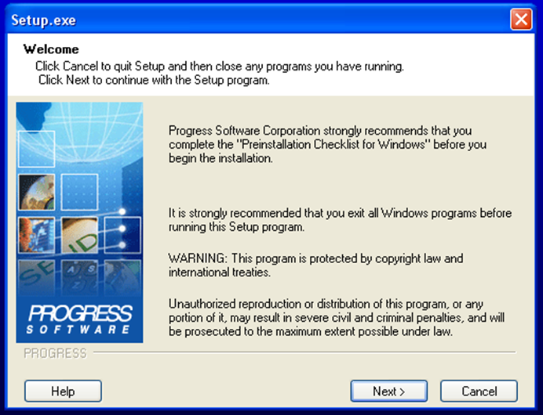

#### Serial Number and Control Codes

Enter your serial and control number for each product that you are installing. Install two products for the server: *OE Workgroup RDBMS* and *Client Networking.* Install one product for the client: *Client Networking.* Then select “***Next***” at the bottom of the screen.

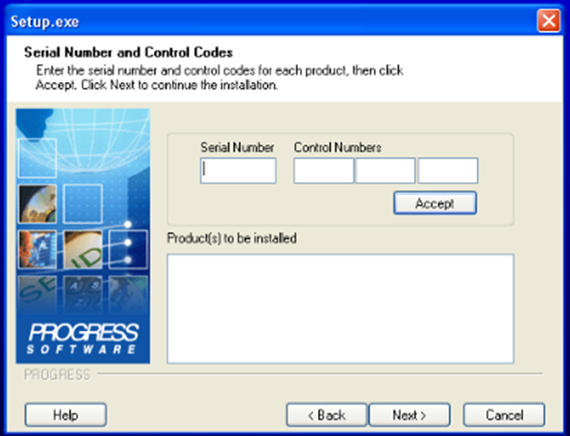

#### License Agreement Screen

Select the ***“Yes”*** button at the bottom of the screen in order to accept the license agreement.

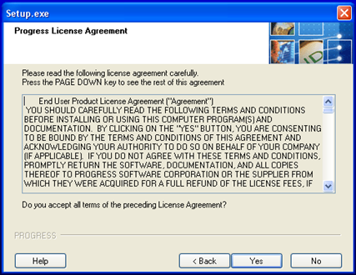

#### Choose Destination Directory and Working Path Directory

Keep the default selections on this screen, and do not attempt any changes. Make sure that the toggle box next to the ***“Complete”*** selection is filled in, then select the ***“Next”*** button at the bottom of the screen.

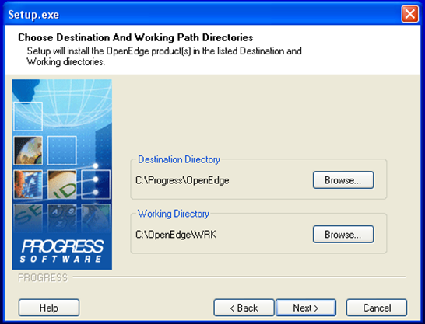

#### Setup Type Screen

Keep the default selections on this screen, and do not attempt any changes. Make sure that the toggle box next to the ***“Complete”*** selection is filled in, then select the ***“Next”*** button at the bottom of the screen.

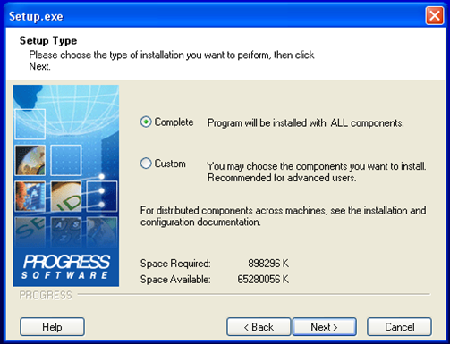

#### Configuring/Installing Components

Keep the default selections on this screen, and do not attempt any changes. Then select the ***“Next”*** button at the bottom of the screen.

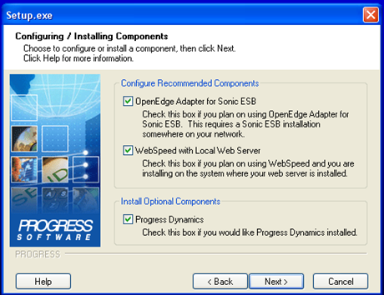

#### Select Program Folder

Keep the default selection for the Program Folder on this screen, and do not attempt any changes. Then select the ***“Next”*** button at the bottom of the screen.

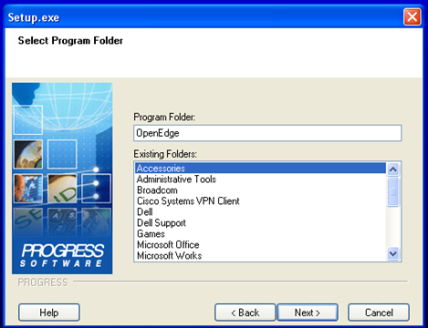

#### Sonic ESB Properties

Keep the default selections on this screen, and do not attempt any changes. Then select the ***“Next”*** button at the bottom of the screen.

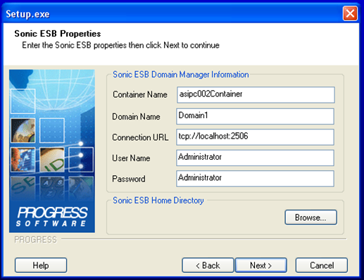

#### Web Server Type

Make sure that the settings for this screen are as follows: Then select the ***“Next”*** button at the bottom of the screen.

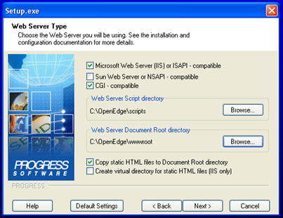

#### Dynamics Options

Make sure that neither of the toggle boxes on this screen are filled in, then select the ***“Next”*** button at the bottom of the screen.

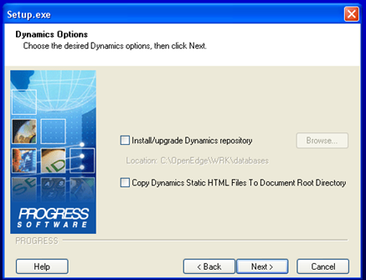

#### Language Choice

Ensure that the default language selection is set to *“English-American”* on this screen. Then select the ***“Next”*** button at the bottom of the screen.

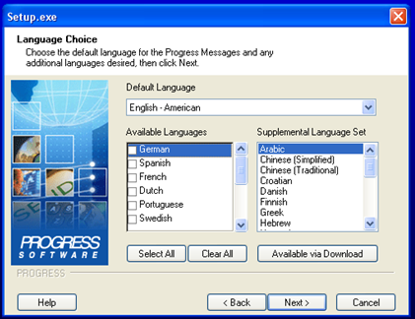

#### International Settings

Keep the default selections on this screen, and do not attempt any changes. Then select the ***“Next”*** button at the bottom of the screen.

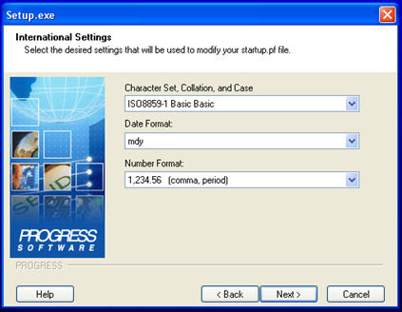

#### Web Services Adapter Settings

Keep the default selections on this screen, and do not attempt any changes. Then select the ***“Next”*** button at the bottom of the screen.

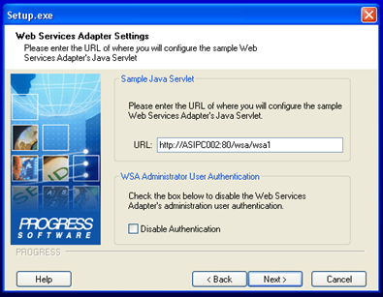

#### Admin Server Authorization Options

Make sure that neither of the toggle boxes on this screen are filled in, then select the ***“Next”*** button at the bottom of the screen.

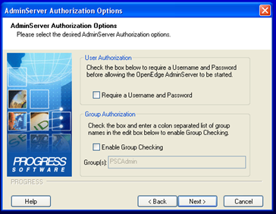

#### Summary Screen

Select the ***“Next”*** button at the bottom of the screen. This will be the last step before the installations starts.

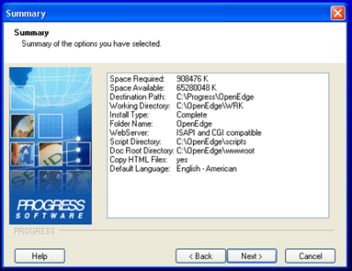

#### Complete Setup Screen

Select the ***“Finish”*** button at the bottom of the screen. This will complete the installation of the base database. The Progress application is now installed on the system.

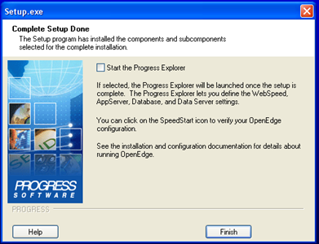

# **Loading Progress**

## Loading Progress on Windows 7-8

### Step One: Disc Drive

Map Disk Drive on Server. For Example N:\ drive

* \\servername\ASIGUI

### Step Two: Install Progress

Install “*Progress*” from N:\Misc\OpenEdge\Setup.exe

* Serial #: Company Specific (No Progress Datasheet)
* Control #: Company Specific (No Progress Datasheet)
* Accept all Defaults
* Install Progress patch 07
  + On Product for workstations – Client networking only.
  + Do not install the database on the workstations.

### Step Three: Copy Folder

Copy the folder N:\MISC\adm2

* Paste it into C:\Progress\OpenEdge\gui
* Create TMP folder on the “C’ drive and also the Windows Directory.
* Change File – C:\Progress\OpenEdge\Bin\
  + Example: prowin32.exe.manifest_old

### Step Four: XPrint Folder

Go to N:\MISC\Xprint 7.9

* Install xprint7.9.exe
  + ***“Right-Click”*** to select “*Run as Administrator*”
* Install xpmail.exe
  + ***“Right-Click”*** to select “*Run as Administrator*”
  + Click ***“Yes”*** on all pop ups.

### Step Five: System Drivers

Go to C:\Windows\System32\drivers\etc\

* Copy the Services file to the desktop and open using Notepad
* Open N:\MISC\serv.txt and Copy all text in document and close
* Go back to Open services file
* Locate Entry before 2600/tcp and create blank line below
* At blank line paste text copied in step 6.b.
* Save and close new Services file – Note if file does not save check the permissions on the services file. Must be full permissions.

### Step Six: Icons

Go to N:\MISC\ICONS. Then copy the “*Advantzware*” shortcut icons to the desktop.

## Loading Progress on Windows Vista PC

### Step One: Install Progress

Install “Progress” from \\corp-4\IT Dept\Progress\setup.exe

* Serial #: Company Specific (No Progress Datasheet)
* Control #: Company Specific (No Progress Datasheet)
* Except all Defaults

### Step Two: Disk Drive

Map Disk Drive on Server. For Example: N:\ drive

* \\adwappsrv01\ASIGUI

### Step Three: Icons

Go to N:\MISC\ICONS

* Copy “Advantzware” shortcut
* Paste this in C:\Users\Public\Desktop

### Step Four: Copy Folder

Copy the folder N:\MISC\adm2

* Paste it into C:\Progress\OpenEdge\gui

### Step Five: XPrint Folder

Go to N:\MISC\Xprint 7.9

* Install xpmail.exe
  + ***“Right-Click”*** to select “*Run as Administrator*”
  + Click ***“Yes”*** on all pop ups.
* Install xprint7.9.exe
  + ***“Right-Click”*** to select “*Run as Administrator*”

### Step Six: System Drivers Part One

Go to C:\Windows\System32\drivers\etc\

* Copy the Services file to the desktop and open using Notepad
* Open N:\MISC\serv.txt and Copy all text in document and close
* Go back to Open services file
* Locate Entry before 2600/tcp and create blank line below
* At blank line paste text copied in step 6.b.
* Save and close new Services file

### Step Seven: System Drivers Part Two

Go to C:\Windows\System32\drivers\etc\

* Locate the “*services*” file rename to services – old
  + Click ***“Allow”*** or ***“Continue”*** on prompts
* Copy the new services file from desktop and paste here.
  + Click ***“Allow”*** or ***“Continue”*** on prompts

### Step Eight: TMP Folder

Create folder TMP in C:\ if it does not exist.

# **PROENV**

## Manually Disconnect User from Database

There may very occasionally be a need to do a manual shutdown of a single user. This can occur if a user is connected to the Progress database and then unplugs their PC, turns off their PC, or loses their network connection (either cabled or RF) while they are still logged into the ASI application and database.

### Step One:

Determine which device needs to be disconnected manually via Proshut.

If a device losses connectivity to the server (as described above) another user will typically get an error message when they are trying to access or post data that is being “held” by the disconnected user.

The error message may be something like:

“Item / Record in use by USER ID PC 1 on PC 999999999999, wait or push cancel to stop”. Where the “USER ID PC 1” is the username assigned to the locked PC and the “999999999999” is the “tty” name of the device.

### Step Two:

You will need to know what drive the ASI database resides on. It is typically on the C or D drive of your server – but, if you do not know do a right mouse click on the start button and go to explore to see where the ASI database is at.

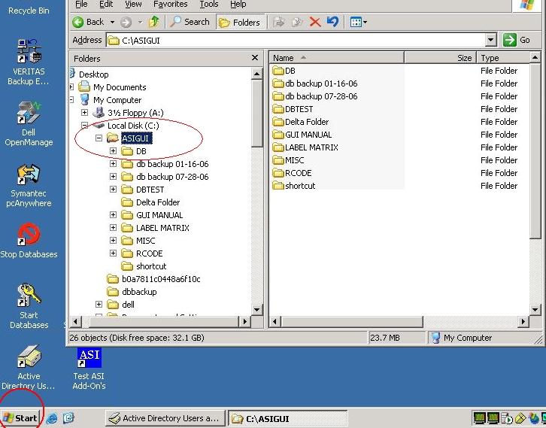

### Step Three:

From the server go to Programs, Progress and select “Proenv”.

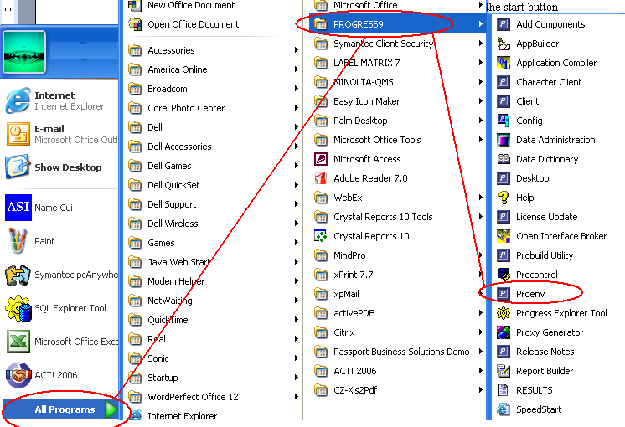

### Step Four:

Proenv will launch a DOS shell looking screen. Type d:/asigui/db/asi <hit enter>

Please Note: If your database is on another drive substitute that drive letter for the d:

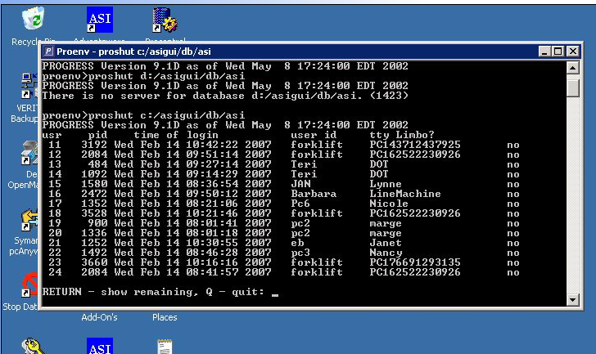

If you have more than 14 connected devices you can hit RETURN (enter) to get to the bottom of the list.

### Step Five:

At the bottom of the list you will see a menu with the option to disconnect a user. Select option #1 and enter the user number of the device that needs to be shut down.

You can then exit this screen.

